**COMP9032 Project – Design Manual**

# **System Control Flow**

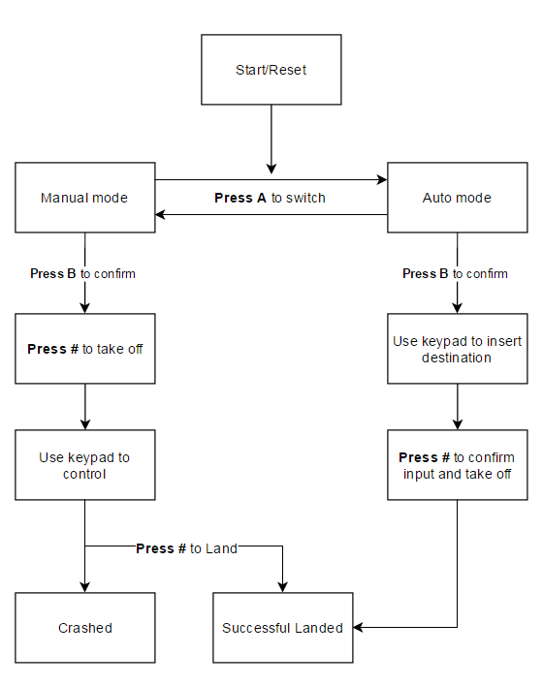

The entire control system is associated with the input signal of the keypad on the AVR lab board. Depend on the flying mode that user has selected, each key on the keypad will act different functions to the flight performance.

## Before take off

* The user needs to press key B to confirm flight mode. E.g. A for auto, M for manual
* In M mode, the user can press # key to perform taking-off, the motor will start spinning with speed of 1m/s
* The default position is x=25, y= 25, z =0 and direction is flying upward
* In A mode, the user will require using keypad to insert the desired destination
* The default destination is x = 40, y=40, z=8 and flying speed 1m/s
* User needs to press key B to perform taking off

## During flying

* In M mode, the key 1, 2, 3, 4 and 6 will be used to change the flying direction, upward, forward, downward, turning left and right respectively
* Key C and D is used to increase and decrease flying speed in between 1- 4
* Key * is used to perform hovering and resume the previous position after hovering
* Key # is perform landing with current position and current speed with downward direction.
* In A mode, no key is required to be pressed.

## End of flight

* In both mode, if the height (z) become zero, the system will treat is as a successful land
* In A mode, although the motor speed has been set up before the flight, the speed will be adjusted automatically to avoid a crash. For example, if the remaining distance is 3 meters and the pre-set speed is 4m/s, the speed will be amended to 3m/s
* In M mode, the flying direction and speed are controlled by the user, if the position is over the boundary of the accessible area, for instance, hitting the ceiling at 10 meters, this will be considered as a crash event.

Following is the detail actions for both manual mode and auto mode while a key is pressed

|  |  |  |
| --- | --- | --- |
| Key | Manual Mode | Auto Mode |
| 0 | N/A | value 0 on LCD |
| 1 | Moving Upward - U | value 1 on LCD |
| 2 | Moving forward - F | value 2 on LCD |
| 3 | Moving downward - D | value 3 on LCD |
| 4 | Rotate to right - R | value 4 on LCD |
| 5 | N/A | value 5 on LCD |
| 6 | Rotate to left - L | value 6 on LCD |
| 7 | N/A | value 7 on LCD |
| 8 | N/A | value 8 on LCD |
| 9 | N/A | value 9 on LCD |
| A | Switch to Auto Mode | N/A |
| B | N/A | confirm Input |
| C | Increase speed by 1 | N/A |
| D | Decrease speed by 1 | N/A |
| * | Hovering/resume previous position - H | N/A |
| # | Take off/ landing | N/A |

# **Data Structures**

## LCD

The LCD is used to display the flying information to the user, following is the data that will be displayed during different stage:

**Start/Reset:**

|  |  |  |  |  |  |  |  |  |  |  |  |  |  |  |  |
| --- | --- | --- | --- | --- | --- | --- | --- | --- | --- | --- | --- | --- | --- | --- | --- |
| S | t | a | r | t | : | ( | M | ) |  |  |  |  |  |  |  |
| K | e | y |  | B |  | t | o |  | C | o | n | f | i | r | m |

By default, the flying mode will be manual which is indicated with M in the first line of the LCD and user can press A key to switch to auto mode. Once A key is pressed, the letter M will switch to A, press A key again will switch back to M mode again.

User then can press key B to confirm flying mode

**Before take off**

In manual mode, the following LCD message will display to guide the user to press Key # to perform take off.

|  |  |  |  |  |  |  |  |  |  |  |  |  |  |  |  |
| --- | --- | --- | --- | --- | --- | --- | --- | --- | --- | --- | --- | --- | --- | --- | --- |
| M |  | m | o | d | e |  | s | e | l | e | c | t | e | d |  |
| K | e | y |  | # |  | t | o |  | t | a | k | e | o | f | f |

In auto mode, the default destination and flying speed (i.e. 40, 40, 8, 1) will be displayed on the screen, the user can then press any number key to insert a valid destination and speed

|  |  |  |  |  |  |  |  |  |  |  |  |  |  |  |  |
| --- | --- | --- | --- | --- | --- | --- | --- | --- | --- | --- | --- | --- | --- | --- | --- |
|  | X |  |  |  | Y |  |  | Z |  |  | S | p | e | e | d |
| 4 | 0 | , |  | 4 | 0 | , |  | 8 | , |  | 1 | m | / | s |  |

A valid key check is used to prevent user insert invalid for the location and flying speed.

For instance, if the user attempts to insert 51 in X or 00 in Y as a destination, the valid key check macro will be triggered (detail algorithm will be explained in the Algorithm section) and only the value that within the constraint destination can be set up.

The user can then press key B to perform take off at any point of the insertion.

**During flying**

When the motor is spinning (e.g. flying in both modes), the following message will be displayed on the LCD and the information will be updated in each second.

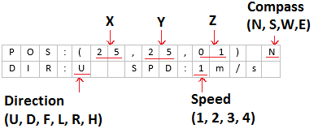

* If the flying Direction is F, the value of X or Y will be updated in regards to the current compass value
* If the flying Direction is D or U, the value of Z will be updated in each second
* If the flying Direction is L or R, all position value will remain the same and the compass value will be updated
* If the key C or D from keypad is press, the speed value will be updated
* If the key * is pressed, the direction value will change to H to indicated hovering mode and no change on the LCD for each second
* If the crash event occurred, the LCD will be frozen with the last positon and speed

**End of the flight**

If the Z value changes to zero, it means a successful flight has been completed and the following message will be displayed to show the final distance and time of the flight

|  |  |  |  |  |  |  |  |  |  |  |  |  |  |  |  |
| --- | --- | --- | --- | --- | --- | --- | --- | --- | --- | --- | --- | --- | --- | --- | --- |
| D | i | s | t | a | n | c | e | : | 4 | 6 | m |  |  |  |  |
| D | u | r | a | t | i | o | n | : | 1 | 4 | s |  |  |  |  |

## LED

At the beginning of the program or after reset, full led bar will be lighted up

During the flight in manual mode, if any valid key is pressed, the led bar will display the corresponding bar as described below:

* Key 1 pressed: 0b00000001
* Key 2 pressed: 0b00000011
* Key 3 pressed: 0b00000111
* Key 4 pressed: 0b00001111
* Key 6 pressed: 0b00111111
* Key # pressed: 0b11110001
* Key * pressed: 0b11110011
* Key A pressed: 0b00010111
* Key B pressed: 0b00110111
* Key C pressed: 0b01110111
* Key D pressed: 0b11110111

If a crashed event occurred, the full light bar will be lighted up for 120ms and turn off for another 120ms and turn on again to form flash

# **Module Specification**

## Macro for LCD:

LCD module:

* This module contains the common function to load and store the data to the LCD via both LCD data and control registers
* “do_lcd_data” is frequently used for print data to LCD

ResetModeMessage:

* This macro is used to print the starting message on the LCD
* It is called once the mode is switched. (E.g. when key A is pressed)

UpdateLCD_1:

* Update LCD data during flying stage
* Input parameters include Position, Compass, Direction and Speed
* Output result to LCD

GetTens:

* Use this macro to break double digit into two unit digits, e.g. 24 -> 2 and 4
* This macro takes one parameter input, e.g. position X and Y
* Output result to a temporary register and use UpdateLCD_1 to print to LCD

## Macro for Auto mode:

DefaultAutoVal:

* Use this macro to assign default values into defined registers for auto mode

SetDestination:

* Print “X Y Z Speed /n 40, 40, 8, 1m/s” message to LCD
* Return cursor to the second line to guide user to insert desired position and speed

EntryDestinationCheck:

* This macro is used to verified the input key and push valid key to LCD
* Once a key is pressed on the keypad, this macro will be trigged with the key value as input
* Following are the checking criteria for each input
  + 1st digit of X: 0-4
  + 2nd digit of X: 0-9, but both digits can’t be zero
  + 1st digit of Y: 0-4
  + 2nd digit of Y: 0-9, but both digits can’t be zero
  + Digit of Z: 1-9
  + Digit of speed: 1-4
* If the pressed key doesn’t meet above criteria, macro ends, no LCD update
* If the pressed key meets above criteria, key value will assign to the register and the key value will be pushed to LCD. At the same time, the cursor will move to next digit on LCD and a digit counter will also be increased by one to indicate next input check.

AssignInput:

* Once the insert key meets the entry criteria, the key value will be assigned to defined register as the destination

AjustmentSpeed:

* The purpose of this macro is to adjust flying speed and avoid crashing in the auto mode
* This macro will find the difference between set destination and current position. If the difference is less than the current speed, the current speed will be changed to the difference
* For example, assuming the destination is 5 meters away and the set speed is 3 m/s, this macro will change the current speed to 2m/s in next second

StartAutoFlying:

* Once key B is pressed, the macro will perform take-off, reach destination and landing actions
* During taking-off, the macro will compare the current Z to expected height, if the height is less than expect height, continue checking height in next second
* Once expected height reached, it will perform rotation and flying forward to the destination.
  + The macro will perform a logical check so that it knows if the destination is larger or smaller than the current position
* Once destination is reached, it will perform landing until height becomes zero

## Macro during flying:

Update_Pos:

* This macro is used to update the total distance based on the flying direction and compass
  + If flying upward: increase total distance by the current speed
  + If flying downward: decreased total distance by the current speed
  + If flying forward: increase total distance by current speed
  + If rotating to right: total distance remains the same, but compass updates direction
  + If rotating to left: total distance remains the same, but compass updates direction

CorrectRotation:

* This macro is to rotate the compass while current direction is either right or left
* It takes two input, such as desired direction and prior direction
  + If destination is on (40, 40) and current position is (25, 25), a right rotation is performed and the desired direction is East
  + If destination is on (20, 20) and current position is (25, 25), a right rotation is performed and the desired direction is West
  + If its current compass is facing North, by using the prior rotation to South, it will perform a single left turn instead of a three right turns to reach wanted direction

Check_Pos:

* This macro checks if current position reached the accessible boundary and causing crashing
* Following are the accessible area:
  + 0 < pos_x < 50
  + 0 < pos_y < 50
  + 0 =< pos_z < 10
* If it excesses any one of above ranges, a crashed event is triggered, otherwise macro ends

MOTOR_SPEED:

* The register ‘curspeed’ is defined to store the value of wanted PWM signal for the motor
* There are five speed levels for the motor to be updated

## Macro for the end of flight:

CrashAction:

* The main output of this macro is set motor speed to zero and flash the LED bar
* A halt loop is set up for the LED bar so no further action can be performed

LandingAction:

* Once the height (Z) become zero, the LCD will display the total flying distance and time

# **Algorithms**

## Keypad

The main loop of this project is scanning if there is any key has been pressed, if a key is pressed, a following key action will take place. In addition, depend on the flying mode, some of the keys will have different functions for its action. For example, key 1 can change flying direction to upward in Manual mode but it also acts as a value 1 during the insertion process in Auto mode.

## Time

One of the main algorithms is using the overflow interrupt to update the status of the AVR lab board in every second. Especially the LCD information.

## Compass

The compass is used to recognised the flying direction after each turn